1. Screenshot result
   1. Awt accumulator

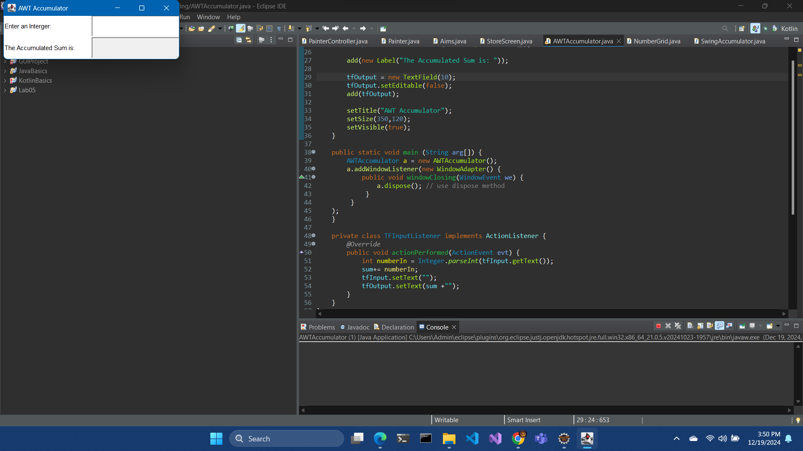

* 1. View store

* 1. View cart

* 1. Update store

* 1. Painter

* 1. Cart screen

* 1. Number grid

1. Updated diagram

